# Java Script

**Program to validate the USN of a student**

<html><head><title>Lab2a</title></head><body>

<h1>Checking USN number</h1>

<hr/>

<script type="text/javascript">

function func(usn)

{ var reg=/[0-9]{4}[/][0-9][0-9]/;

if(!usn.value.match(reg)||usn.value.length>7)

{ alert("Invalid,Enter valid USN");

return false;

}

else

alert("its valid");

}

</script><form>

Enter USN <input type="text" name="usn" size="30">

<input type="button" value="check" onclick="func(usn)">

</form></body></html>

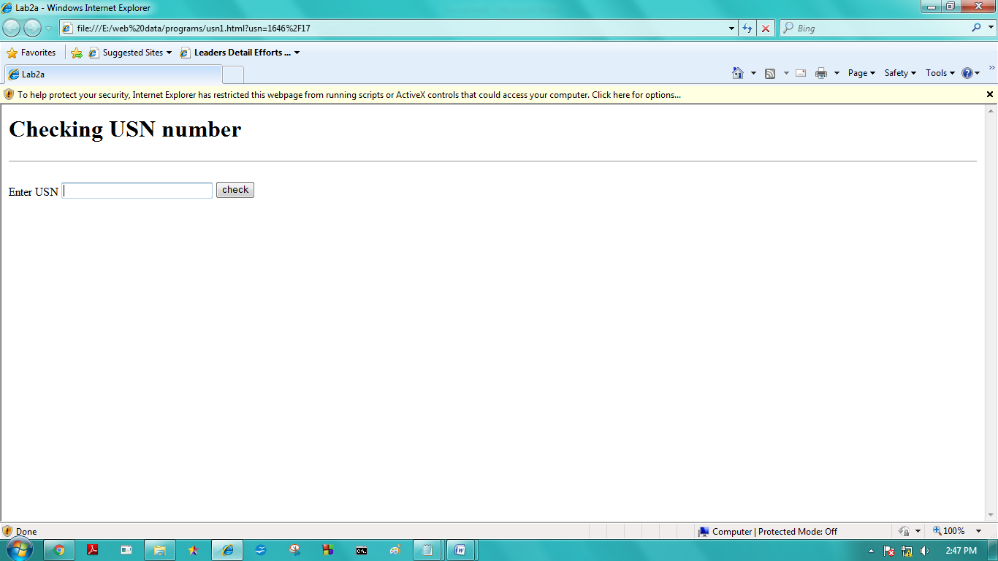

# CSS Positioning Properties

# ABSOLUTE POSITION

Live Demo

<html> <head> </head> <body>

<div style = "position:absolute; left:80px; top:80px; background-color:yellow;">

This div has absolute positioning.

</div>

//-->

</style></head></body></html>

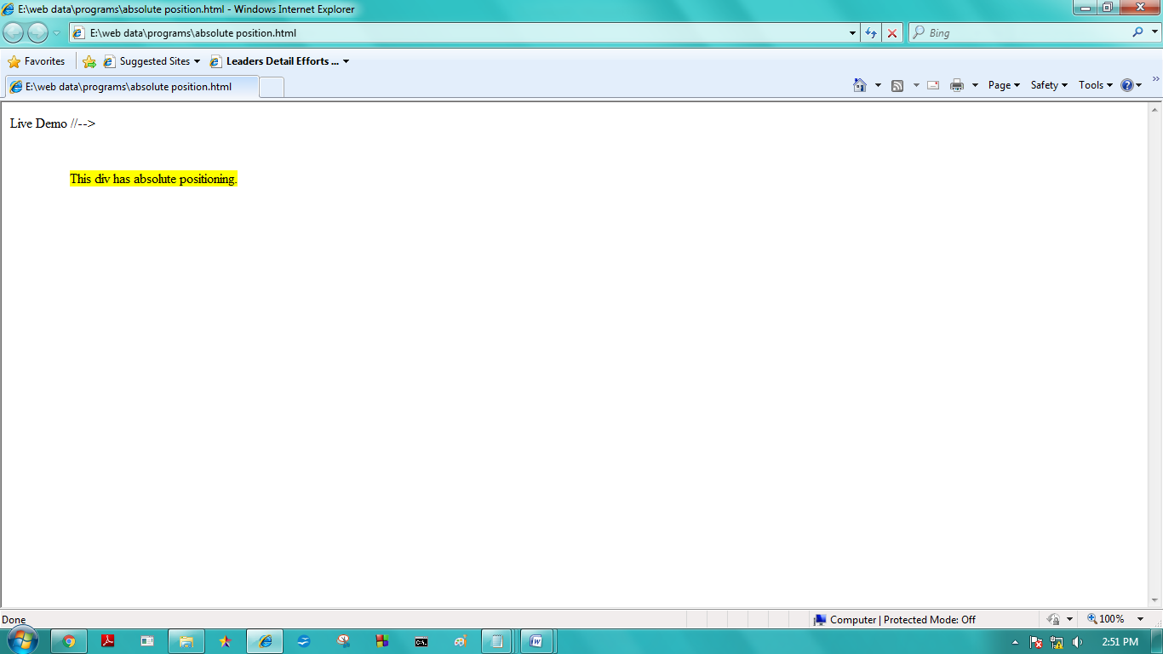

# FIXED POSITION

<html> <head> <style>

p.pos_fixed {

position: fixed;

top: 50px;

right: 5px;

color: blue; }

</style> </head> <body>

<p>Some text...</p><p>Some text...</p><p>Some text...</p><p>........</p><p>.... ...</p

><p>........</p><p>........</p><p>........</p><p>........</p>

<p>........ </p><p>........</p><p>........</p><p>........</p><p>........</p>

<p>........</p><p>........</p><p>Some text...</p><p>Some text...</p><p>Some text...</p>

<p class="pos_fixed">This is the fix positioned text.</p>

</body> </html>

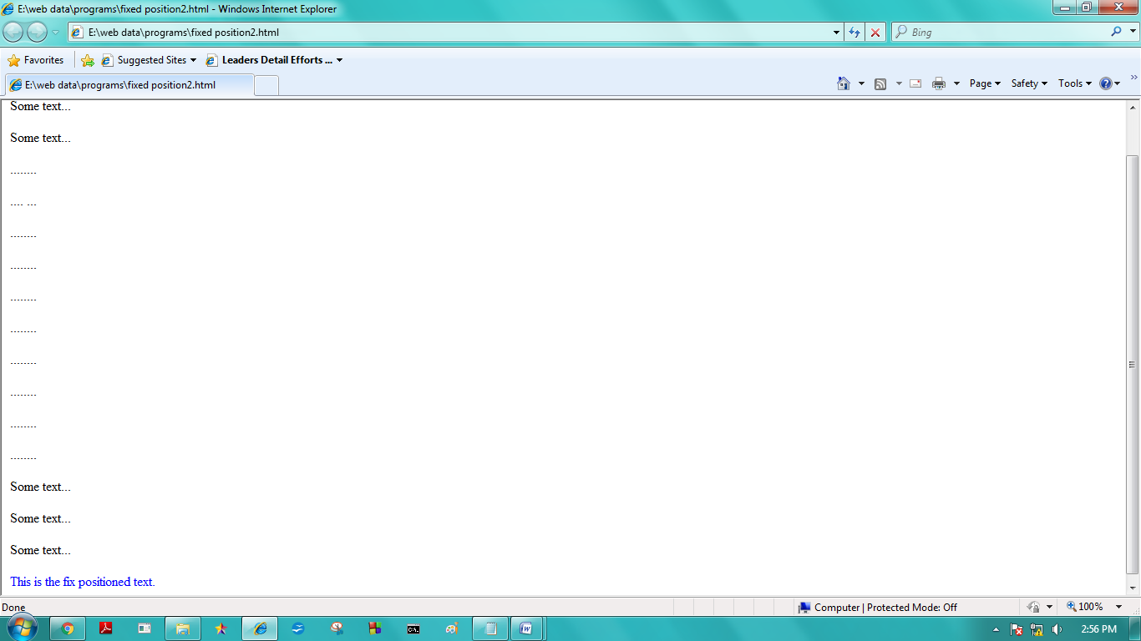

# RELATIVE POSITION

<html><head></head> <body>

<div style = "position:relative; left:80px; top:2px; background-color:yellow;">

This div has relative positioning.

</div> </body></html>

